Design Section

The headings below are intended as guides. You may find that you do not need all of them. Sections 1 – 5 and 11 – 15 are compulsory.

Kerboodle section 7.2 gives useful advice on completing this document.

1 Outline System Design

1.1 System Flow charts

See attatched image files
Main_System_Flowchart
Kruskals_System_Flowchart
Primms_System_Flowchart

2 User Interface Design

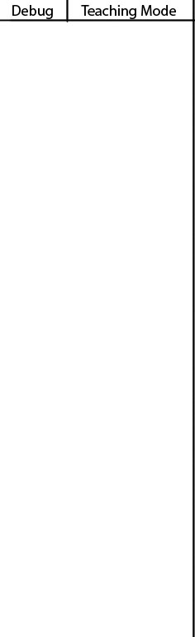
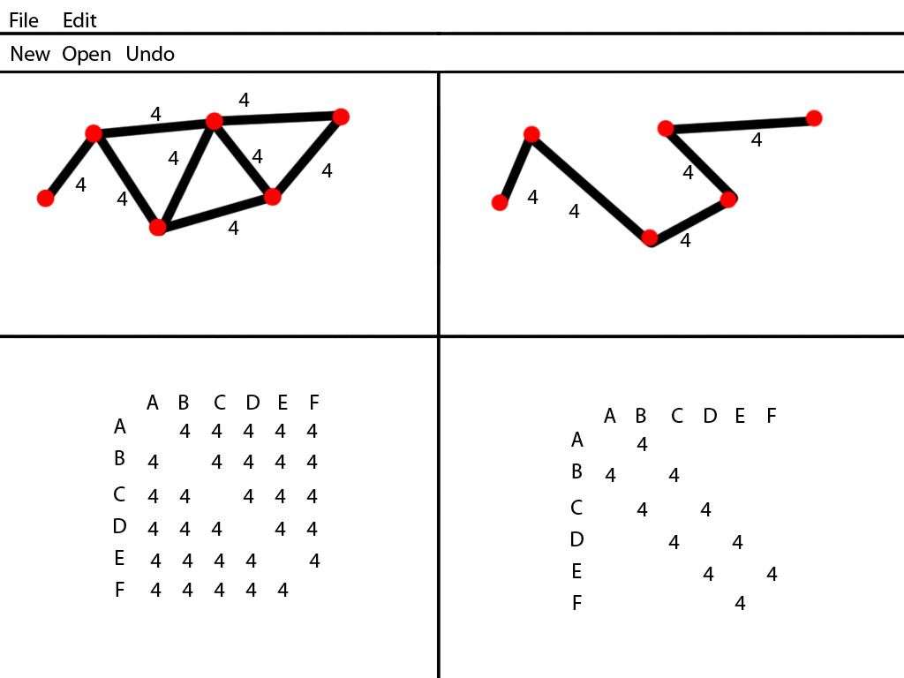
Concept

The idea here is to have 4 separate sections, all resizable to custom sizes and all able to be minimised. The panel on the right hand side is what tells the student what is happening and why in terms of the D1 mathematics course E.G:
-Ordering the edges into ascending order and printing this list
-Choosing the lowest of these and stating which it is
-Checking if it forms a cycle and therefore stating if it is added or if its rejected due to a cycle.

The debug is to track what is happening in the project E.G:
-Explaining the different possible outcomes of the analysis of a connection, and what is found about it such as the connection AD is not in any existing trees so a new tree is created.
-The saving of files
-The drawing of GUI

The top left panel is an area to draw the original problem in the form of a graph, using a mouse,
The bottom left panel is an area to enter the original problem in the form of a matrix table.

The top right panel is an area to show the solution to the problem in the form of a graph,
The bottom right panel is an area to show the solution to the problem in the form of a matrix table.

In both cases I plan for it to generate the 3 other boxes based on the one used to enter data.

Beta Design, resized.

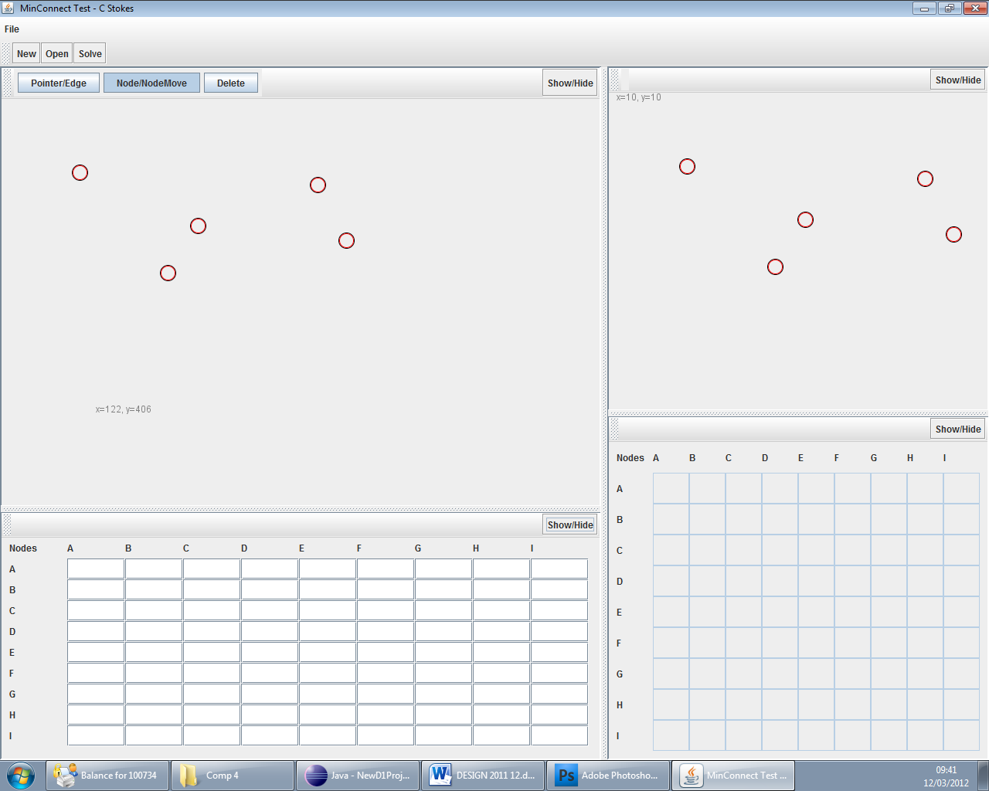

3 Hardware Specification
The system will need at least 1024mb of ram, a hard drive for storage, and input methods such as a keyboard and mice. The resolution as the screen should be 1024x768 pixels to allow the graphics to be shown clearly. The clients computers more than fulfil this specification and should not pose a problem. There is no plan to incorporate printing at this moment in time.

4 Program structure

See image file

You may like to include either hierarchy charts (p253) or structure charts here, or any other recognised form for describing the overall structure of your program. Describe the java classes you will set up and explain the relationships between them (inheritance or aggregation) and document the constructor parameters. A complete list of all public methods and their parameters could also go here or in the Systems Maintenance section.

5 Design Data Dictionary
All data will be stored locally as strings in a text file, each problem will have its own folder with three text files, one for each of the nodes, edges and connections.
The data will be stored in a CSV style such as
nodeID nodeLabel yCoOrd xCoOrd on each line
There will be a settings file for all the static variables such as the node diameter, for each problem.

Node
Name | Example | Description
Node ID | 1 | A uniquely identifying integer number assigned to each node on creation.
Y Co-Ordinate | 125 | The Y position of the node as an integer, used by the graphics package to draw it to the GUI.
X Co-Ordinate | 125 | The X position of the node as an integer, used by the graphics package to draw it to the GUI.
Node Label | A or NodeA | Most commonly used as single characters but has the support to be more than one character, is drawn to the GUI as this and is used by the user to identify different nodes. Unique.

Edge
Name | Example | Description
Edge ID | 1 | A uniquely identifying integer number assigned to each Edge on creation.
Connected Nodes | 2|3 | Must be separated by a | and denotes the two nodes the edge connected. Will be stored as ID to recover.
Weight | 8 | An integer value which denotes the value of the edge, this is the thing we are trying to minimise with our algorithms.

Connection
Name | Example | Description
Connection ID | 1 | A uniquely identifying integer number assigned to each Connection on creation.
Nodes | 2|3 | Must be separated by a | and denotes the two nodes the edge connected. Will be stored as ID to recover the node object.
Edge | 1 | Will be stored as ID to recover the edge object.

6 Object diagrams and class definitions

Complete this section only if relevant to your project. See textbook page 255.

7 Data structures
There are arrayList dynamic data structures for edges, nodes and connections throughout the entire problem, each type of object has its own global list to hold all objects of this type as well as being used in lower scopes to make copies of the list, and for subtrees as subtrees are just a list of connections.

There are queues/stacks going to be used within the individual algorithm so that connections are considered in the correct order, as they are sorted into ascending queues or stacks.These will have local scope within methods.

My whole project is based on the data structure of connections, these are made by myself and contain 2 node objects and a connection object as well as their ID. An arraylist of these connections then create a graph as it contains all the information needed to draw and solve the problem. Tree’s are dynamic and connections can be added or removed without recreating objects.
Complete this section only if you plan to use any dynamic data structures in your program e.g. a list, queue, stack, linked list, graph, or binary tree.

8 File organisation

Files will be organised by having all problem files in one folder, the folder is saved to or opened and contains 3 text files, each containing data for the list of edge, node or connection objects respectively, separated by spaces. No databases are used.

11 Algorithms

Using a recognised method (pseudocode or flowchart) describe the main algorithms that your program will need to implement. See p255 for a pseudocode example.

Kruskals

Var solutionTree ← new solutionTree() //Empty solution tree
Var problemGraph ← userInput
sortedConnections ← sortConnections(problemGraph.getAllConnections)
caseForConnection = caseForConnection(sortedConnection.remove)
switch(caseForConnection)
case 0:
Create new tree and add this connection to it
Break
case 1:
Add connection to this tree
Break
case 2:
Combine both Trees and add connection to combinedTree
Break
Case default:
Reject as cycle
break

sortConnections(connectionList) //Sorts the connectionList in ascending order
Var currentHighest ← 0

int caseForConnection(ConnectionIn)
int count;
for every tree that is not the problemGraph
for every Connection in that tree
if ConnectionIn == Connection
count++
end if
end for
return count

Saving
ArrayList<Object> ← allOfThatObject //all objects have an arraylist containing all of them
File F ←object.txt

For ArrayList.size()
String[] details ←object.getAllDetails
for I ← 0 ; i<details.size ; I ←I+2 //Only print every other detail to avoid getting titles
F.printline(details[I])
End for
End for
Repeat for each kind of object

Opening
rrayList<Object> ← allOfThatObject //all objects have an arraylist containing all of them
File F ←object.txt
Scanner sc ← scan(F)
While there is a next line
Scanner lineScan ← sc.nextLine()
object x ← new Object(lineScan.nextToken(), lineScan.nextToken(), lineScan.nextToken())
Object.getArrayList.add(x)
End While
Repeat for each kind of object

Primms

Var StartingNode ← userInput
Var solutionTree ← new solutionTree() //Empty solution tree
Var problemGraph ← userInput
Add startingNode to nodeList
Do
Var jointConnections ← findCompliantJointConnections(nodeList)
Add lowestJointCompliantConnection to solutionTree
For each Node in lowestJointCompliantConnection
If nodeList.contains thisNode
Then do nothing
Else
Add this node to nodeList
While(solutionTree.getNumberOfConnections() != problemGraph.getNumberOfNodes() -1)

/*
*Finds all connections that are able to be added, this means they join to existing *connections and will add a new node
*/
Function findCompliantJointConnections(nodeList)
Loop through every Connection in startGraph
Loop for every Node in currentSolution
If Connection contains thisNode
Then if Connection !contain anotherNode in nodelist
Then add thisConnection to returnList
return connections

Connection.getWeight() //Returns the weight of the edge
Return connection.weight

getNumberOfConnections()//Returns the total number of connections
return solutionTree.getConnectionList().size()

getLowestConnection(connectionList)
Var lowest = null
For each Connection in connectionList
If lowest = null OR currentConnection.getWeight() > lowest.getWeight()
Then lowest = currentConnection
end if
end for
return lowest;

13 Detailed design of printed output

All text output will be placed in the debug window, in one of two windows; the debug tab for what is going on in the program and all the algorithm details, and the teaching mode tab displays all information about the problem for a maths student. All other output will be placed either in user defined places or one of nine pre-determined locations at sensible distances apart. The user defined places are put in on the left hand panel via mouse movement and reflected appropriately in the right. The left hand is input and the right hand output.

Plan out the exact co-ordinates of any reports you want to print from java as you have to position al output accurately on the paper when you program. It is possible to design a report in Access and call it up from java but this will be given less credit. There is an example of a mail merge letter on p256, which shows a mail merge designed within from MS Word (not really in the spirit of the new spec)

14 Preliminary test plan

See p257 for an example of an outline and detailed test plans.

15 Detailed test data

It is important to plan tests for normal, valid, invalid and boundary data. Each individual test plan needs to include a test number, the purpose of the test, a description of how it will be done, example of test data, expected result for each piece of test data, a record of whether the test behaved as expected and a cross-reference to an appendix containing screenshot evidence for each test. Remember that testing is designed to try and break your program and then fix it.

